C**This file contains basic user instructions for navigating the GUI, for the code documentation, check out the readme.txt file

Table of Contents:

1. Installing MATLAB – page 2
2. Installing the app + dependencies – page 2
3. Installing Chrome & downloading Chromedriver – page 3
4. Welcome Screen – page 3
5. Neuron Worksheet Report Generator – page 4
6. Soma Brain Area Locator – page 5
7. Registration Display Settings Record – page 7
8. Registration Result Folder Maker – page 8
9. Temporary Curation Folder Maker – page 9
10. Curation Helper – page 10
11. Database Sample and Neuron Entry – page 15
12. Unfinished Neuron Mover – page 16
13. Installing MATLAB
    1. The instructions for installing the latest version of MATLAB can be found at \\dm11\mousebrainmicro\SOP\How to install latest MATLAB.docx
14. Installing app & dependencies
    1. Go to <https://www.python.org/downloads/release/python-3810/> and scroll all the way down to select the Windows installer (64bit) for Python 3.8.10
       * Make sure the “Add Python 3.8 to PATH” option is checked during installation
       * Choose the default install options
    2. Go to <https://github.com/Elsayedaa/MLDAMS>
    3. 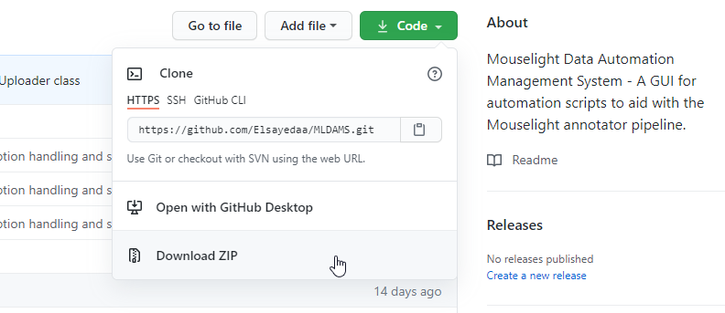click the ‘Code’ icon in the github page and then click ‘Download Zip’
    4. Unzip the app folder into the **same folder that you installed MATLAB, if you used the default install path this should be C:\Program Files**
    5. Find the installdependences.bat file and double click it
       * **Note: If you are not working with an administrator account, you will need to run installdependencies.bat as admin**. Right click the file and click “Run as Administrator”
    6. This batch script will create a virtual python environment called mldamsenv in the app folder which contains all the necessary dependences to run the app, these include:
       * Matlab engine, Openpyxl, pandas, numpy, requests, gql, Pillow, html-table-parser-python3, selenium
       * Note: if you want to install dependencies for the installation of the app that is on dm11, you will have to run the bat and [install matlab engine separately](https://www.mathworks.com/help/matlab/matlab_external/install-the-matlab-engine-for-python.html) , **make sure to install it to the mldamsenv enviornment in the dm11 install folder**
    7. You can then run the app via the Startapp.bat file, which links the virtual environment installation of python to the app’s main script
15. Installing Chrome and downloading Chromedriver
    1. Download google chrome from [here](https://www.google.com/chrome/)
    2. Follow the instructions from the installer to install the browser
    3. The directory for Chromedriver.exe is \\dm11\mousebrainmicro\Mouselight_Data_Management\Chromdriver
    4. Chromedriver version 91 is currently in the directory, if you have installed google chrome version 91, you don’t need to do anything else.
    5. Chrome 91 is the latest version of chrome at the time of writing. If you have a newer version, you will get a warning in the command window behind the app window.
    6. 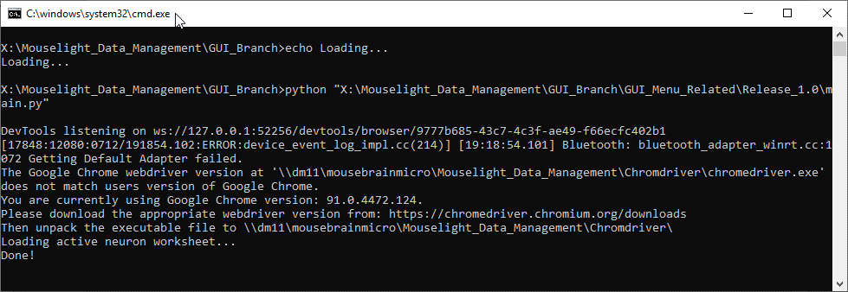[Download the latest Chromedriver](https://chromedriver.chromium.org/downloads) and unpack it to the Chromedriver directory
16. 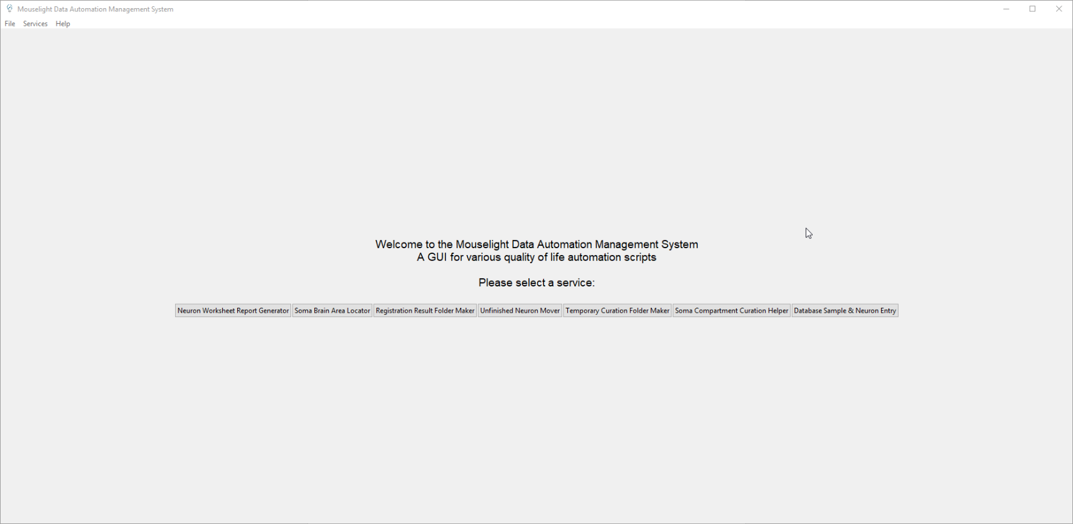Welcome Screen:
    1. Upon starting MLDAMS, you will first see the welcome screen with the buttons for all the available services laid out horizontally.
    2. Services can also be accessed via the ‘Services’ tab on the top menu bar
    3. Each service has a ‘Return to main menu’ button, but you can also return to the main menu via the File tab>Main Men
17. 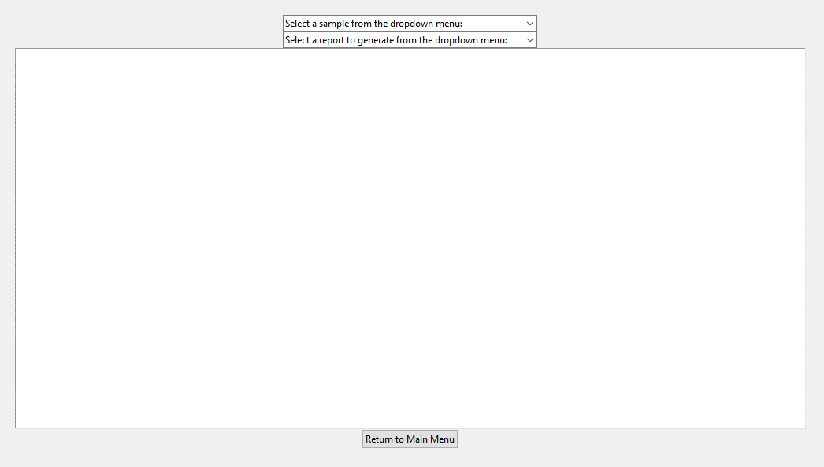Neuron Worksheet Report Generator
    1. The first tab on the left grants the user access to the Neuron Worksheet Report Generator, which allows the user to automatically generate reports regarding the status of a sample in the Active Neuron Worksheet.
    2. Upon selecting an active sample from the top dropdown menu, the program will gain access to the contents of that excel sheet.
    3. The user can then select a report to generate via the second dropdown menu, which will be printed to the textbox below.

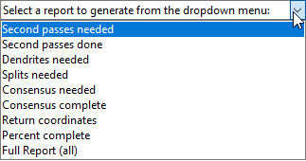

1. 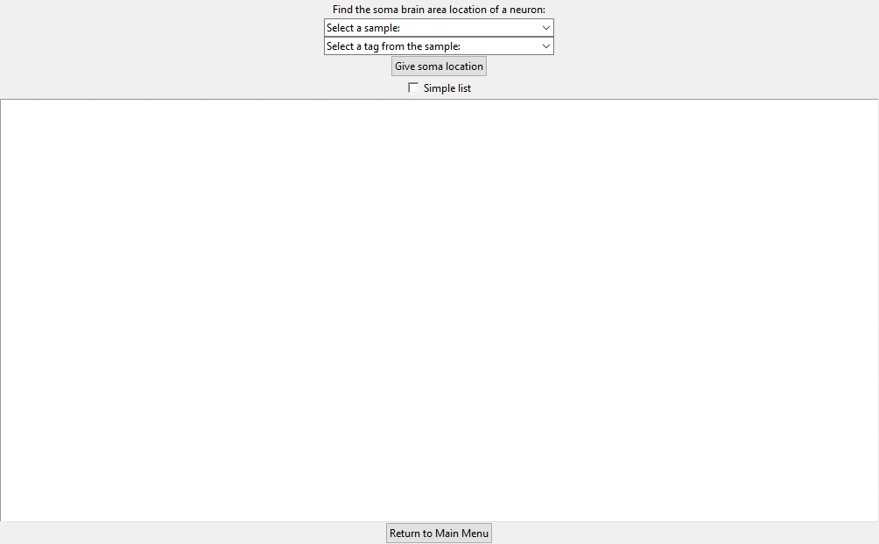Soma Brain Area Locator
   1. The Soma Brain Area Locator allows the user to check the brain area locations in which the roots of a particular neurons are encapsulated.
   2. 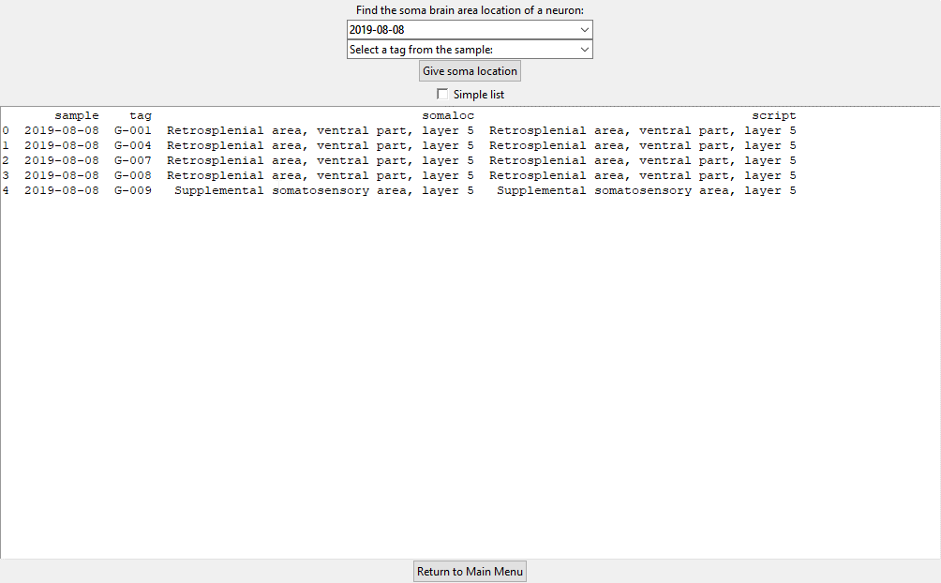The user can select a sample and get all the soma locations of its neurons by keeping the tag dropdown menu blank and clicking the ‘Give soma location’ button.
   3. Doing this will generate a breakdown of each neuron consisting of its parent sample, its tag, its curated soma location (under ‘somaloc’), and its MLCuration.m script generated soma location (under ‘script’).
   4. 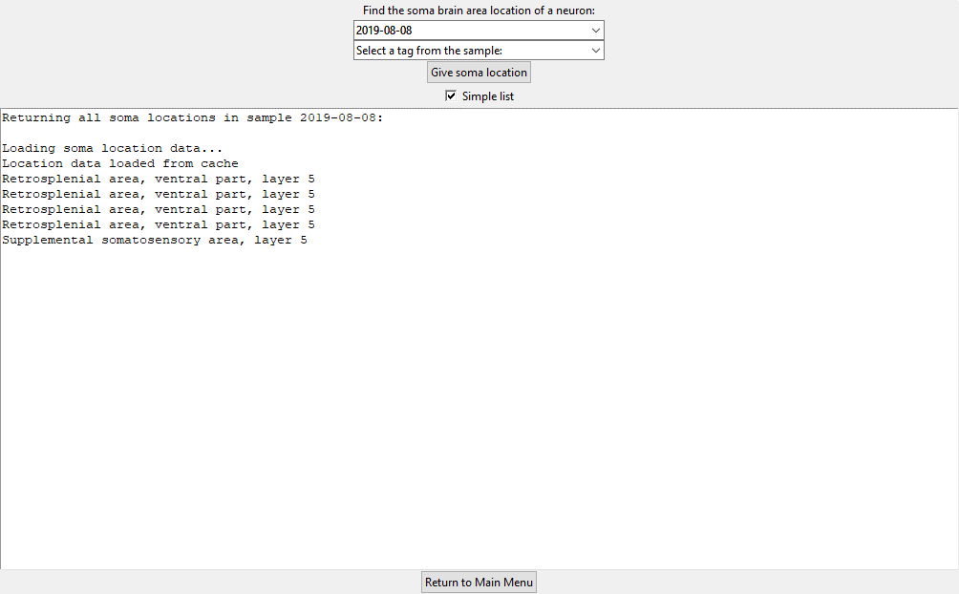The user can also check the ‘simple list’ checkbox to return only a list of the curated soma locations.
   5. 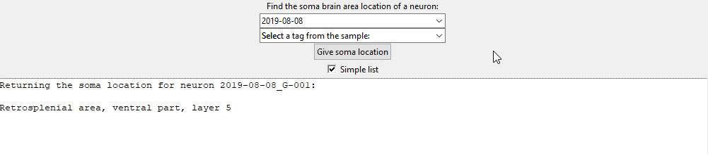Furthermore, the user can return the curated soma location of a single neuron by selecting it from the 2nd dropdown men and clicking ‘Give soma location’

1. 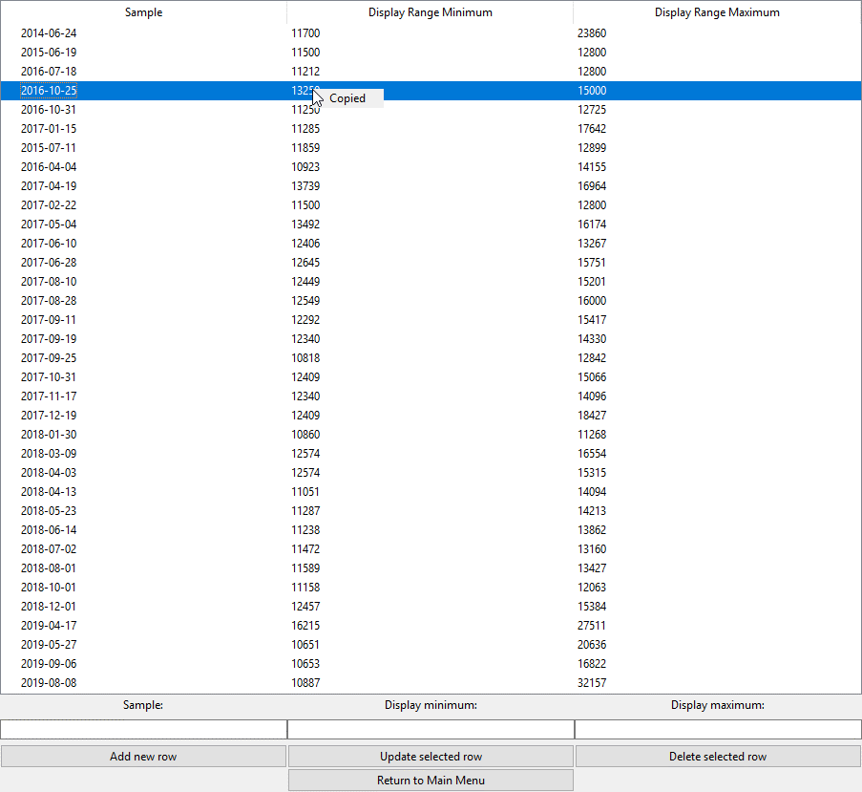Registration Display Settings Record
   1. This service allows the user to store the display range settings taken from the sample registration process.
   2. Saves any entered settings to the displaySettings.json file found at \\dm11\mousebrainmicro\registration\Database\
   3. This is an important step linking sample registration and sample curation because the display range value for a sample in the displaySettings.json is used to run the MLCuration.m script.
   4. Whoever is doing sample registration should save the display range for the sample they’re working on in here.
   5. You can also copy the display range to aid in your registration (the numbers are used multiple times) by clicking the value with the left mouse button.
   6. Type in the sample in YYYY-MM-DD format and enter 5 digit values for the display minimum and display maximum
   7. Add new row to add a new row to the record, select a row and press update selected row to update the saved values with your entered values, or press delete selected row to remove it from the record.
2. 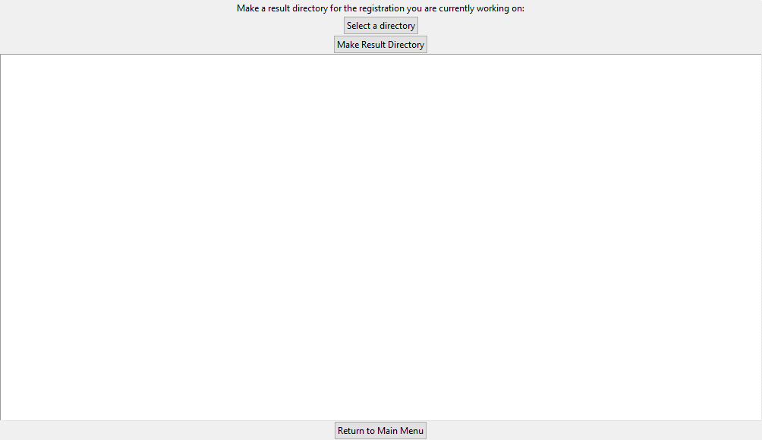Registration Result Folder Maker
   1. This service helps the user with the ‘Creating Final Displacement Field’ step of the sample registration process.
   2. It essentially creates a folder inside the sample registration parent folder called ‘Result’, which contains all the necessary files to create the final displacement field
   3. To create the result folder, click the ‘Select a directory’ button and select the parent folder of the registration from the file dialogue (which will automatically open to the main registration folder)
   4. After selecting the sample folder, click ‘Make Result Directory’
3. 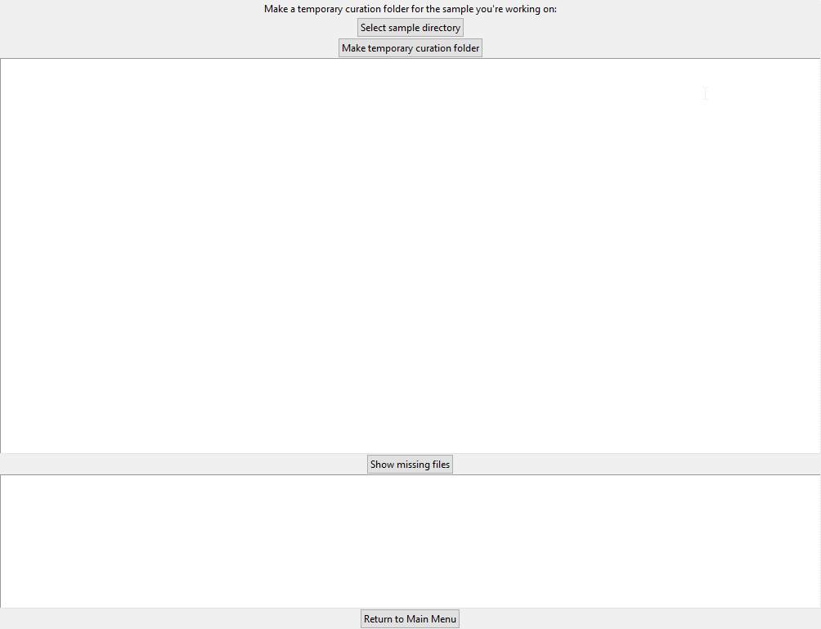Temporary Curation Folder Maker
   1. This service allows the user to create a folder containing all consensus and dendrite swc files that have been completed for a sample.
   2. This is done as part of the curation process to allow the user to load all completed tracings into a new workspace quickly.
   3. To select a sample, click the ‘Select sample directory’ button. This will bring up a file dialogue (opens on the Finished Neurons directory by default) for the user to choose a sample folder.
   4. After selecting a sample, click the ‘Make temporary folder’ button.
   5. You can check if any files are missing from any of the neuron folders by clicking the ‘Show missing files’ button. If no files are missing, nothing will appear in the text box below.
4. 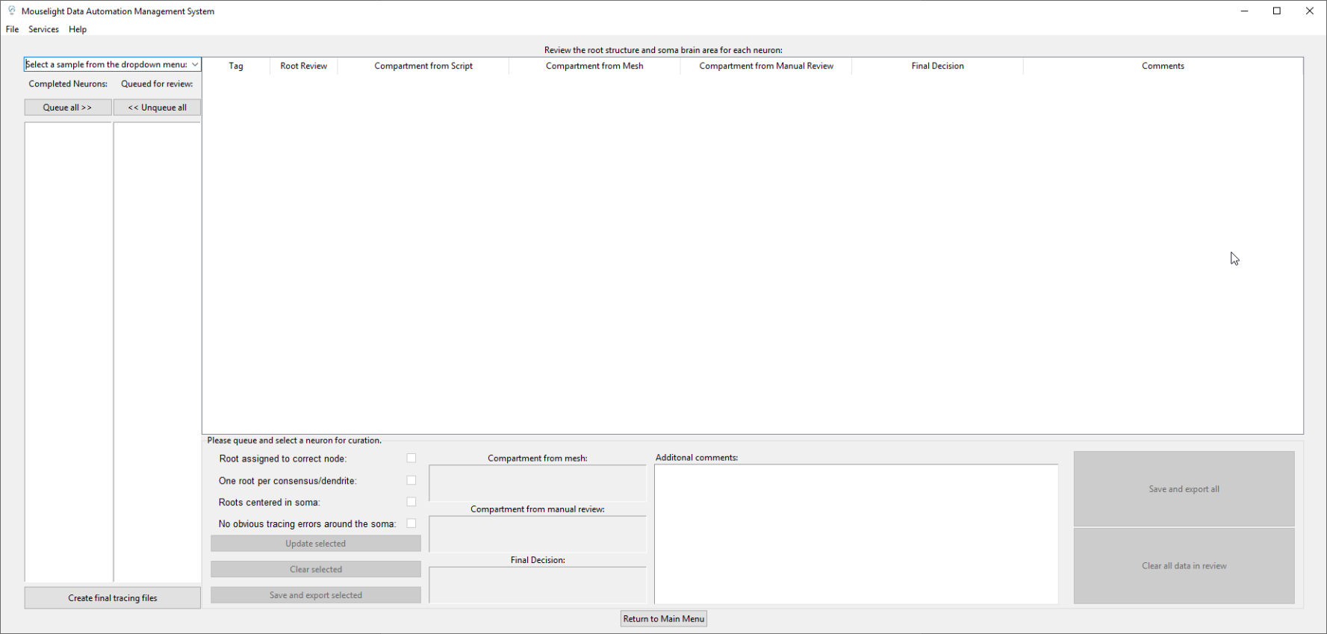 Curation Helper
   1. This service helps the user keep track of all the steps needed to complete the curation process. It also allows the user the create the final tracing files that will be uploaded to the Neuron Browser database.
   2. After creating the temporary curation folder and loading the swcs into a new curation workspace, the user should pull up this service to begin the curation process.
   3. 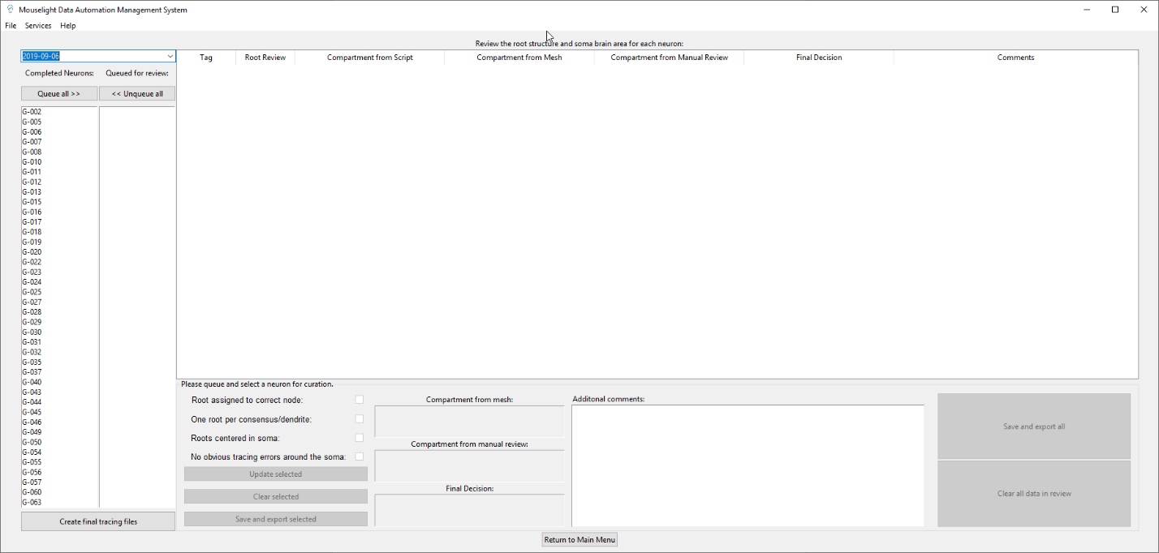Upon selecting a sample for curation, the finished neurons in the sample will be loaded into the ‘Completed Neurons’ column.
   4. After this, the user needs to queue neurons for review. This can be done by clicking a neuron individually in the ‘Completed neurons’ column. You can also queue all the neurons at once by clicking the ‘Queue all’ button
   5. 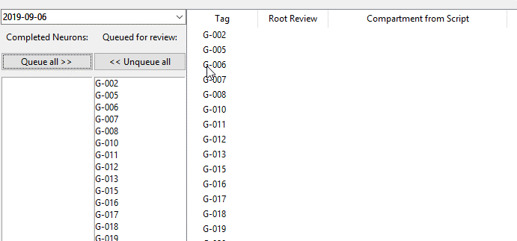Upon queuing a neuron for review, it will appear in the review table
   6. A neuron can be selected for data entry by clicking it’s associated the row in the review table.
   7. Be aware that clicking a neuron in the ‘Queued for review’ column will not select it for data entry, but rather unqueue it
   8. 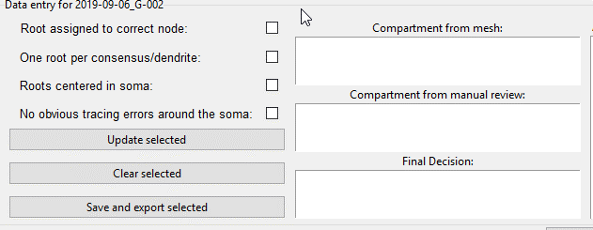If ‘Queue all’ is clicked, the top neuron in the ‘Queued for review’ column will automatically be selected for data entry
   9. The steps of the curation process can be done in any order, however here is the recommended order of operations. It is highly advised to follow this order of steps.
      * Complete the root review by checking off the items in the checkboxes for the neuron you are reviewing. After completing the root review for a neuron, click ‘Update selected’. The ‘Root Review’ column will then be marked as ‘Complete’
      * Repeat for all the neurons that you have queued.
      * Click the ‘Create final tracing files’ button to run the MLCuration.m MATLAB script for all the neurons you have queued. 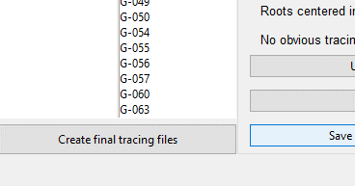
      * Wait while the script runs, it can take several minutes to finish.
      * 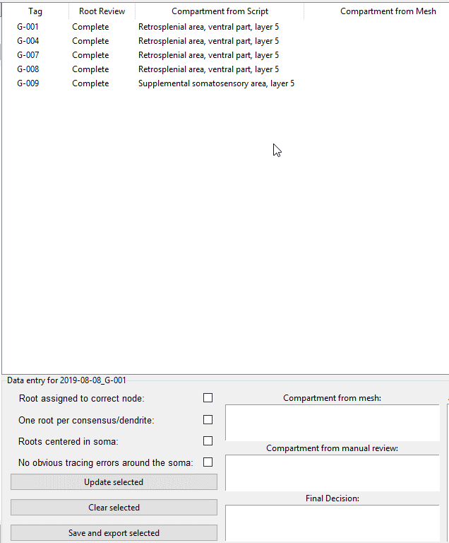After the script is done running the ‘Compartment from Script’ column will be populated automatically
      * Now you need to review if the output of the MLCuration.m script is correct. Using the [Allen Coronal Mouse Brain Atlas](http://atlas.brain-map.org/atlas?atlas=1&plate=100960520#atlas=1&plate=100960520&resolution=NaN&x=2200.034907826206&y=2031.849399365877&zoom=-1&z=8) and Horta 2D in your curation workspace, enter what you think is the correct soma compartment in the ‘Compartment from manual review’ entry box.
      * You can also load brain area meshes into your workspace to see if the root of your neuron is encapsulated by a specifc mesh. If you use this method, enter the brain area in the ‘Compartment from mesh’ entry box. Alternatively, you can leave it blank if you do not use the mesh method.
      * Finally, enter the final decision for the correct brain area in the ‘Final Decision’ entry box. If your final decision is the same as the MLCuration.m script output, you can leave it blank, **but it is preferred if you enter it anyway for recordkeeping**.
      * 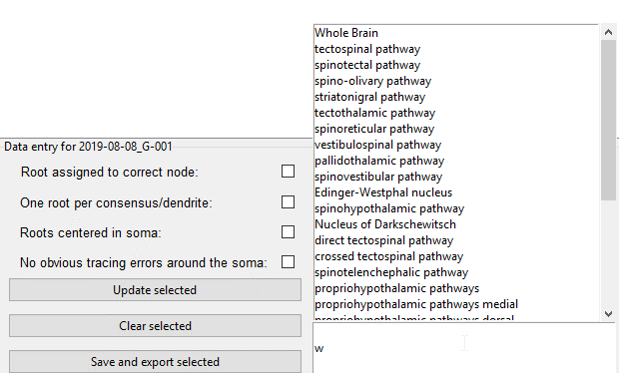Your entry into the ‘Final Decision’ entrybox will be aided by a popup menu containing all brain areas defined by the Allen Mouse Brain Atlas ontology that will appear when you begin typing. As you type, the number of selections that appear will be narrowed down to best predict your entry.
      * You **must** select your entry from the popup menu or else you will get an error message once you try to click ‘Update selected’. This is done by design to prevent typos from going into the Neuron Browser database since the ‘Final Decision’ entry will eventually be the one that is entered into the database (if not blank).
      * Optionally, you can enter additional comments concerning the neuron in the ‘Additional comments’ section.
      * After you have finished entering your data for a specific neuron, click ‘Update selected’ to update the review table. You can then click ‘Save and export selected’ to save the neuron you are currently entering data for; or you can move on to the next step and click ‘Save and export all’ later on.
      * Repeat the soma compartment review for every neuron that you have queued for review.
      * MAKE SURE TO SAVE YOUR WORK!!
      * 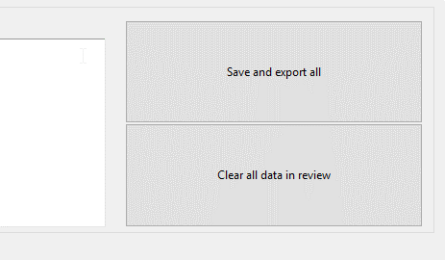 You can either save each neuron individually after you finish entering its data or save all of the data you have entered so far by clicking the ‘Save and export all’ button.
      * After the curation process is complete, you can then enter the data into the Neuron Browser database automatically using the ‘Database Sample & Neuron Entry’ service.
5. Database Sample & Neuron Entry
   1. 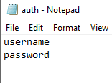Before starting, enable automatic authentication by creating a text file named ‘auth’ in the **Database_Related_GUI_Branch** folder. Then, enter your HHMI username and password in the file.
   2. Your username should be the top line, and your password should be the following line.
   3. If this step is skipped, the user will have to manually enter their username and password into the browser when it pops up on sample data entry
   4. Upon starting this service, you will be greeted by a window asking you to select a database.

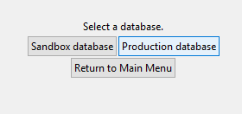

* 1. 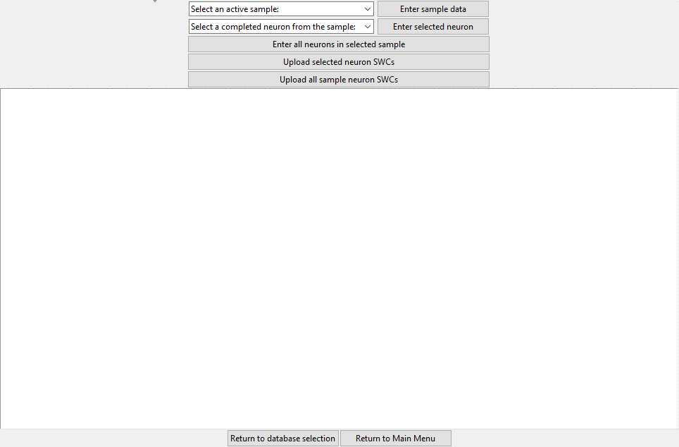The Sandbox database button will lead you to a version of the Database Sample & Neuron Entry service that posts data to a test version of the database. This is mainly used for development purposes and can be ignored (unless you want to make changes to the source code of the service – if so, please test out the changes you make on the Sandbox database before you start using them for the Production database).
  2. After selecting a database, you will enter the main window.
  3. To post a sample data to the Neuron Browser sample manager database, select your sample from the top dropdown menu and click the ‘Enter sample data’ button.
  4. You can then post neurons to the sample you just posted individually by selecting them from the second dropdown menu and clicking the ‘Enter selected neuron’ Button.
  5. You can also post all of the complete neurons in the sample by clicking the ‘Enter all neurons in selected sample’ Button.
  6. After posting the sample and its neurons, you can then upload them individual or you can upload all of the complete ones in the sample by clicking their respective button

1. 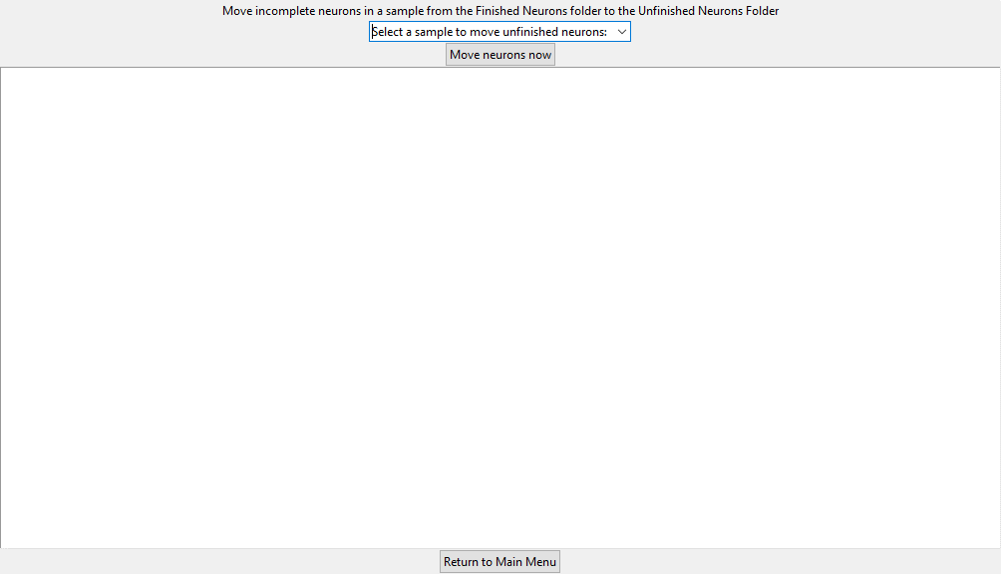 Unfinished Neuron Mover
   1. This service is **ONLY TO BE USED AFTER YOU ARE SURE THE SAMPLE IS COMPLETED AND YOU ARE NOT GOING BACK TO IT.**
   2. Use this service to move all of the unfinished neurons in a sample folder inside the “\\dm11\mousebrainmicro\shared_tracing\Finished_Neurons” directory to its corresponding sample folder in the “\\dm11\mousebrainmicro\shared_tracing\Unfinished_Neurons” directory
   3. Unfinished neurons are defined as all neurons which exist in the sample folder and do not appear in the ‘Consensus complete’ report retrieved from the Neuron Worksheet Report Generator. (ie: they don’t have a consensus date on the Active Neuron Worksheet)
   4. To move the unfinished neurons, simply select the sample from the dropdown menu and click ‘Move neurons now’